NSA NAPLES SUmmer TOWN HALL addendum

Follow-up to Questions from the June 4th Town Hall

Table of Contents
General Questions 2
In regard to hiring with HR, how are the most qualified candidates selected? 2
Child Youth Program (CYP) 2
Why are pre-school children not allowed to go to SAC over the summer break before they are 5 years old? 2
DoDEA 2
Facilities at school are unsatisfactory (ex. bathrooms missing doors), is there anything that could be done to address this? 2
Housing 2
Can Housing work to provide a smaller window of time for waiting on work/ service teams to arrive on appointment days? 3
Can dog waste bins be relocated to paths more commonly used by dog walkers? 3
MWR/MWR Services 3
Will swimming lessons outside of normal business hours be provided to accommodate those who work? 3
U.S. Naval Hospital Naples 3
How is PCS season going to affect care at the hospital? 3
NEX/Commissary/Theater 3
Can the commissary get two-seater shopping cars, like from the NEX? 4
Does a policy exist that prevents self-checkout before 10am? 4
Safety 4
Can the base implement a bike safety class for minors? 5
Security 5
Where are the crime reports, and can they be presented at Area Orientation again? 5
Public Works (PWD)/Environmental 5
Can a covered walkway be looked into for pedestrians walking from the West Parking Garage? 5
Can the crosswalks leading to the school be repainted? 5
Will TNR (Trap Neuter Release) be allowed to operate on base during kitten season? 5

General Questions

In regard to hiring with HR, how are the most qualified candidates selected?
- Please see https://www.secnav.navy.mil/donhr/Overseas/Pages/default.aspx for all questions related to HR policies

Child Youth Program (CYP)

Why are pre-school children not allowed to go to SAC over the summer break before they are 5 years old?
- OPNAV Instruction 1700.9E Chapter 7. states that SAC programs shall provide safe, supervised, healthy, accountable and age-appropriate activities and environments for children in kindergarten through sixth grade, ages five through twelve
- We look forward to seeing our youth transitioning from Sure Start to kindergarten in our fall program

DoDEA

Facilities at school are unsatisfactory (ex. bathrooms missing doors), is there anything that could be done to address this?
- DODEA facilities are critical to the installation, DODEA Staff works directly with NSA Naples Public works and Mirabella to address issues. If you are aware of an unresolved issue (discrepancy w/o a trouble ticket attached), please contact the main office at the school and report it
- If you are aware an unresolved issue for an extended period of time or an emergency item, please submit an ICE comment to BOTH NSA Naples School Liaison and the school Directly

Housing

Can Housing work to provide a smaller window of time for waiting on work/ service teams to arrive on appointment days?
- The current appointment windows allow the warehouse contractor sufficient times to allow for any delays with all deliveries scheduled for each time window
- Contract guidelines, which are agreed upon through Fleet Logistics Center and the Office of General Council every five years, must be adhered to
- We will continue to work with all stakeholders to find ways to improve our processes

Can dog waste bins be relocated to paths more commonly used by dog walkers?
- Yes, please contact housing if you have a route that could use an additional pet waste bin

MWR/MWR Services

Will swimming lessons outside of normal business hours be provided to accommodate those who work?
- MWR is looking at potential offerings

U.S. Naval Hospital Naples

How is PCS season going to affect care at the hospital?
- There may be instances when it may take longer to see your provider. In anticipation of the PCS season, U.S. Naval Hospital Naples has plans to minimize clinical disruptions for our patients throughout the summer months
- For known events such as sports physicals or wellness exams, our best advice is to plan ahead and schedule early
- We also advise patients to cancel appointments they are not planning to show for, as no call/ no show appointments happen often and take time from other patients
- Should you need to be seen for urgent/emergent medical issues, our emergency department is available 24/7

NEX/Commissary/Theater

Can the commissary get two-seater shopping cars, like from the NEX?
- 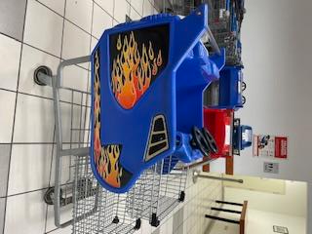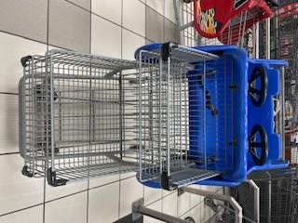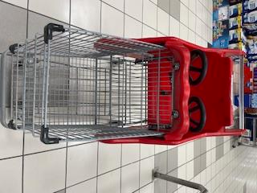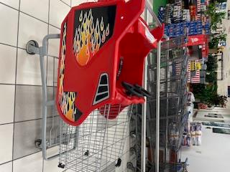
(Images of two-seater shopping carts available at the commissary)
- On a yearly basis, the commissary may procure more shopping carts depending on budget

Does a policy exist that prevents self-checkout before 10am?
- No – self check out is available from 09:00 a.m. to 10:00 a.m. Tellers and front workers have been briefed on this policy

Safety

Can the base implement a bike safety class for minors?
- Our Safety department has received this feedback and are working to produce a bike safety course which will award a certificate on completion
- We will provide more updates as we receive them

Security

Where are the crime reports, and can they be presented at Area Orientation again?
- The crime trend reports, and the crime prevention video have been posted on NSA Naples Security page on the command website
- India-7 (I-7) does run presentations available at Area Orientation to discuss crime prevention trips in the local area

Public Works (PWD)/Environmental

Can a covered walkway be looked into for pedestrians walking from the West Parking Garage?
- We are considering this as a long-term investment in our facility

Can the crosswalks leading to the school be repainted?
- Yes, PWD will initiate a service request to the lessor and address the repainting of the school crosswalks
- Additionally, a separate, more holistic project will address crosswalks throughout the remainder of the installation

Will TNR (Trap Neuter Release) be allowed to operate on base during kitten season?
- Trap/Neuter/Release (TNR) cannot be officially implemented due to a Chief of Naval Operations Policy Letter that forbids the establishment of TNR programs on Naval Installations
- We want to remind community members that adoption is an option and the veterinary clinic on base can assist you in getting any adopted pets registered and ready in the U.S. system

